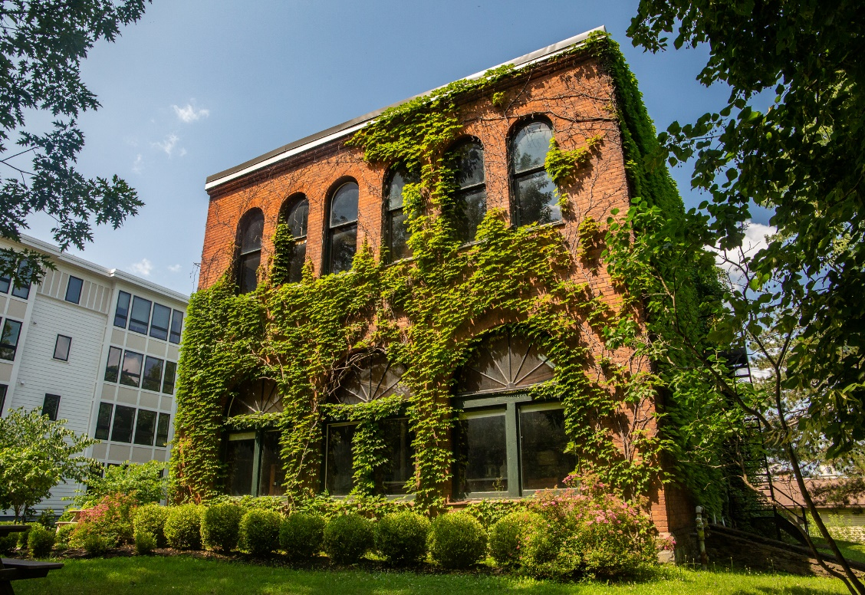

MINIMUM CAPACITY :-

The Minumum intake capacity

of students is between 3000-4020

children

LIBRARY :-

The Libarary is Available.

CANTEEN:-

The Canteen Facility is Available.

BOARDING :-

No availablility of boarding.

SPORTS :-

There are different categories

sports available.

Girls Volleyball

Boys Volleyball

Football

|  |  |  |
| --- | --- | --- |
| CASCADILLA SCHOOL ITHACA - SCHOOL |  |  |
|  |  |  |
| School Detail :- Cascadilla School is a co-ed preparatory school, in Ithaca, New York, established in 1876 as a tutoring and college preparatory school for Cornell University. Cascadilla School is a co-ed preparatory school, in Ithaca, New York, established in 1876 as a tutoring and college preparatory school for Cornell University. Cascadilla School is a co-ed preparatory school, in Ithaca, New York, established in 1876 as a tutoring and college preparatory school for Cornell University. Cascadilla School is a co-ed preparatory school, in Ithaca, New York, established in 1876 as a tutoring and college preparatory school for Cornell University. |  |